**Task Web Scrapping**

**Import Library and Web:**

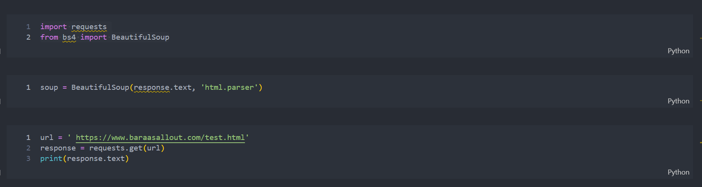

**Task 1**

* **Extract Text Data:**

**● Extract all headings (<h1>, <h2>).**

**● Extract all text content inside <p> and <li> tags.**

**● Savethis data into a Extract_Text_Data.CSV file.**

**●** [**https://www.pythontutorial.net/python-basics/python-write-csv-file/**](https://www.pythontutorial.net/python-basics/python-write-csv-file/)

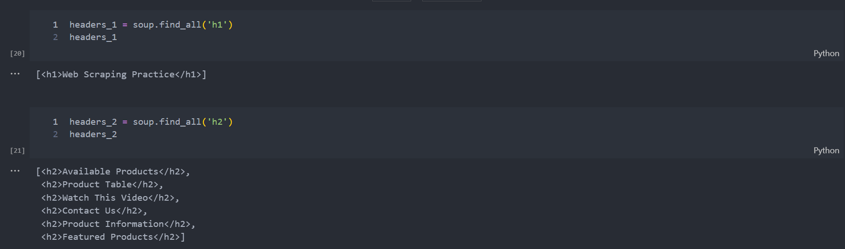

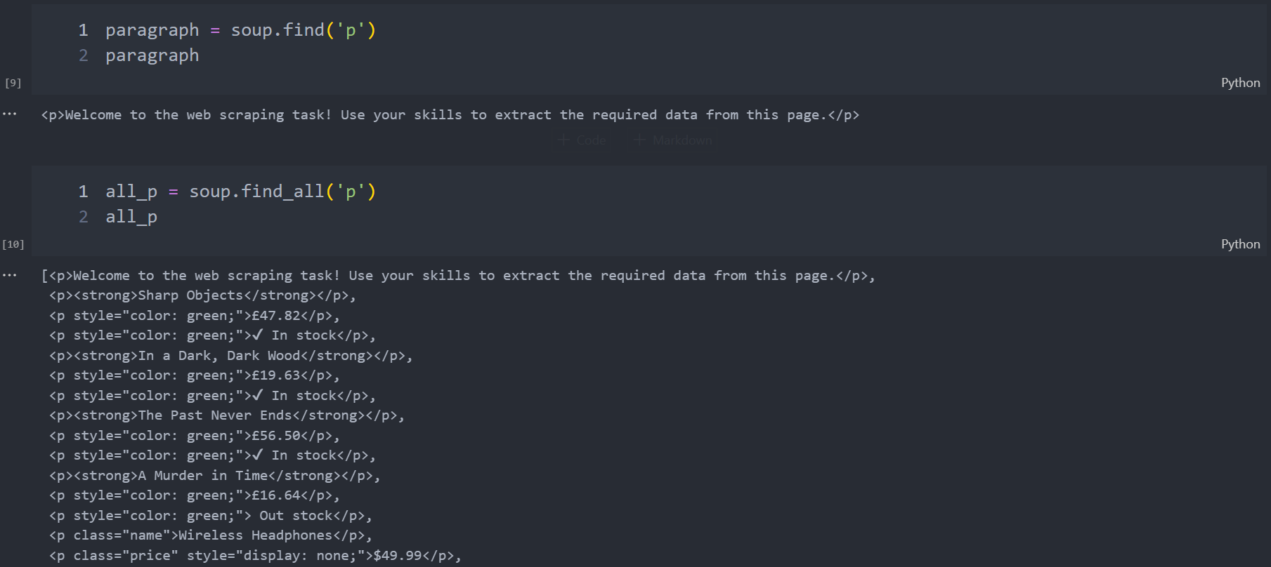

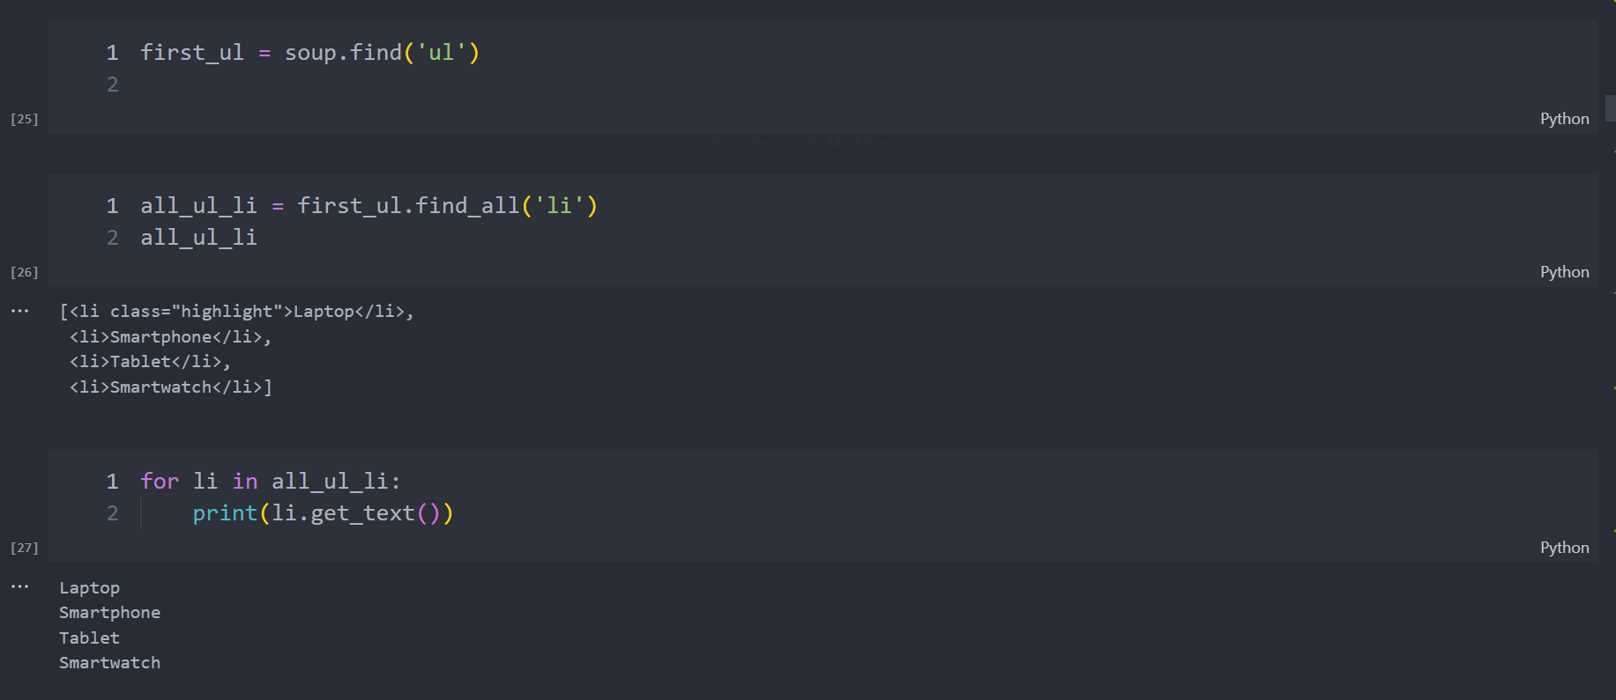

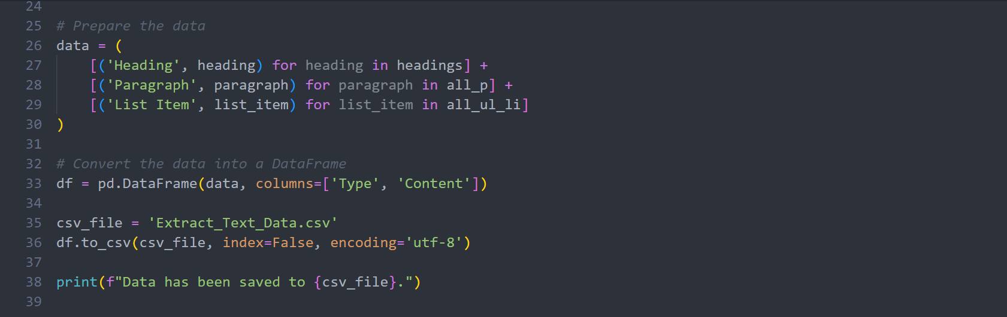

**Task 2**

* **Extract Table Data:**

**● Extract data from the table, including:**

**● Product Name.**

**● Price.**

**● StockStatus.**

**● Savethis data into a Extract_Table_Data.CSV file.**

**●** [**https://www.pythontutorial.net/python-basics/python-write-**](https://www.pythontutorial.net/python-basics/python-write-)

**csv-fil**

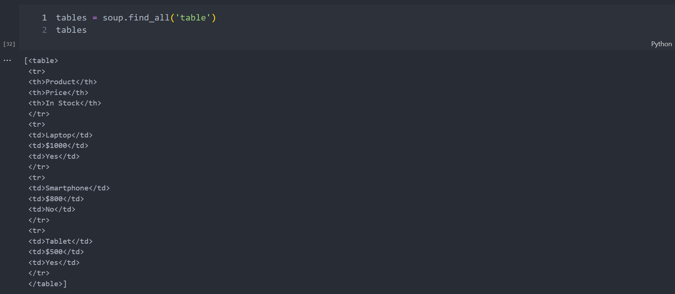

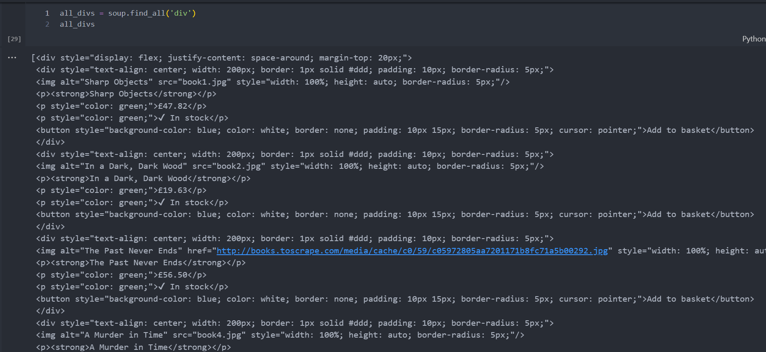

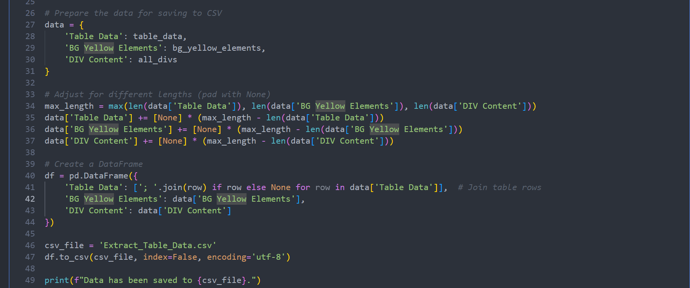

**Task 3**

* **Extract Product Information (Cards Section):**

**● Extract data from the book cards at the bottom of the page, including:**

**● BookTitle.**

**● Price.**

**● StockAvailability.**

**● Button text (e.g., "Add to basket").**

**● Savethedata into a Product_Information.JSON file.**

**●** [**https://www.geeksforgeeks.org/how-to-convert-python- dic|**](https://www.geeksforgeeks.org/how-to-convert-python-%20dic|)

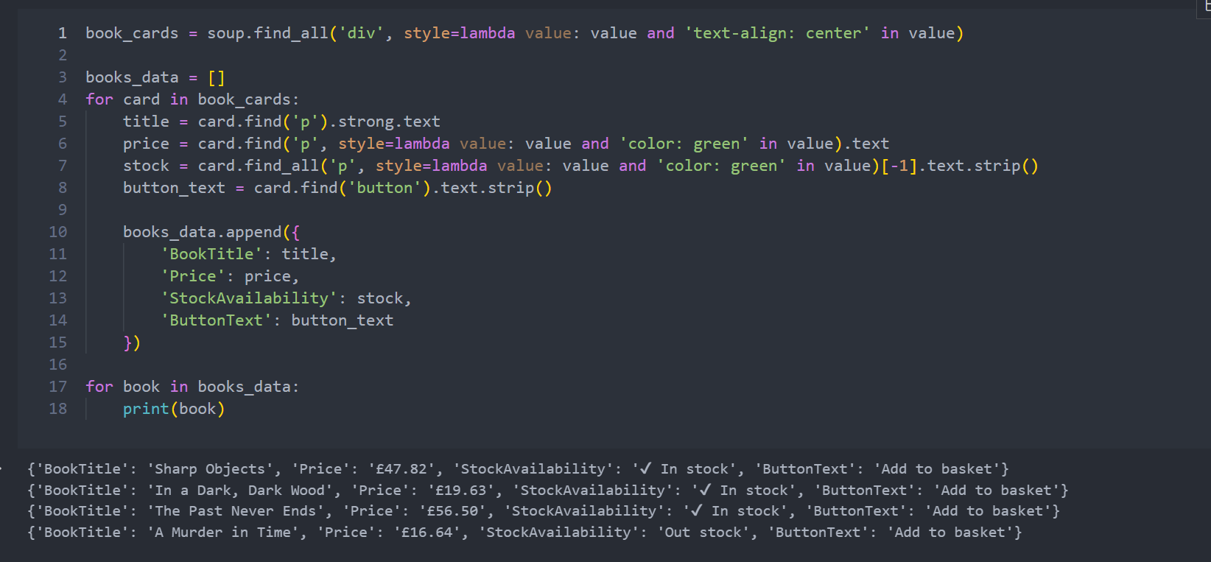

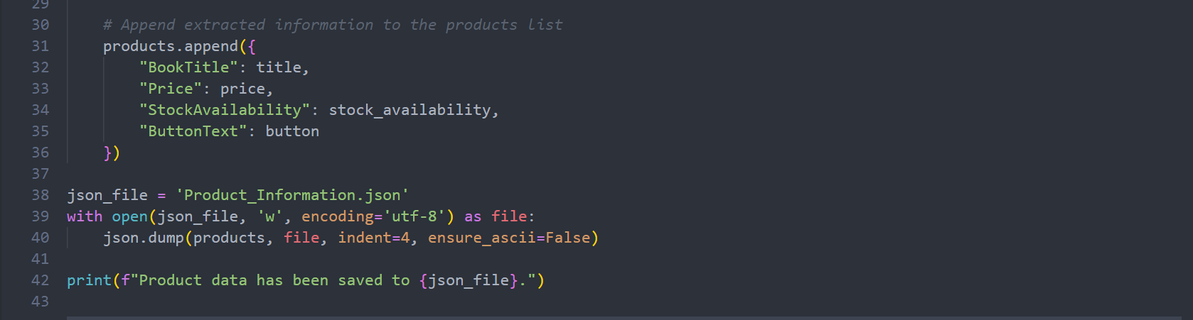

**Task 4**

* **Extract Form Details:**

**● Extract all input fields from the form, including:**

**● Field name (e.g., username, password).**

**● Input type (e.g., text, password, checkbox, etc.).**

**● Default values, if any.**

**● Savethedata into a JSON file.**

**●** [**https://www.geeksforgeeks.org/how-to-convert-python-dictionary-to-json/**](https://www.geeksforgeeks.org/how-to-convert-python-dictionary-to-json/)

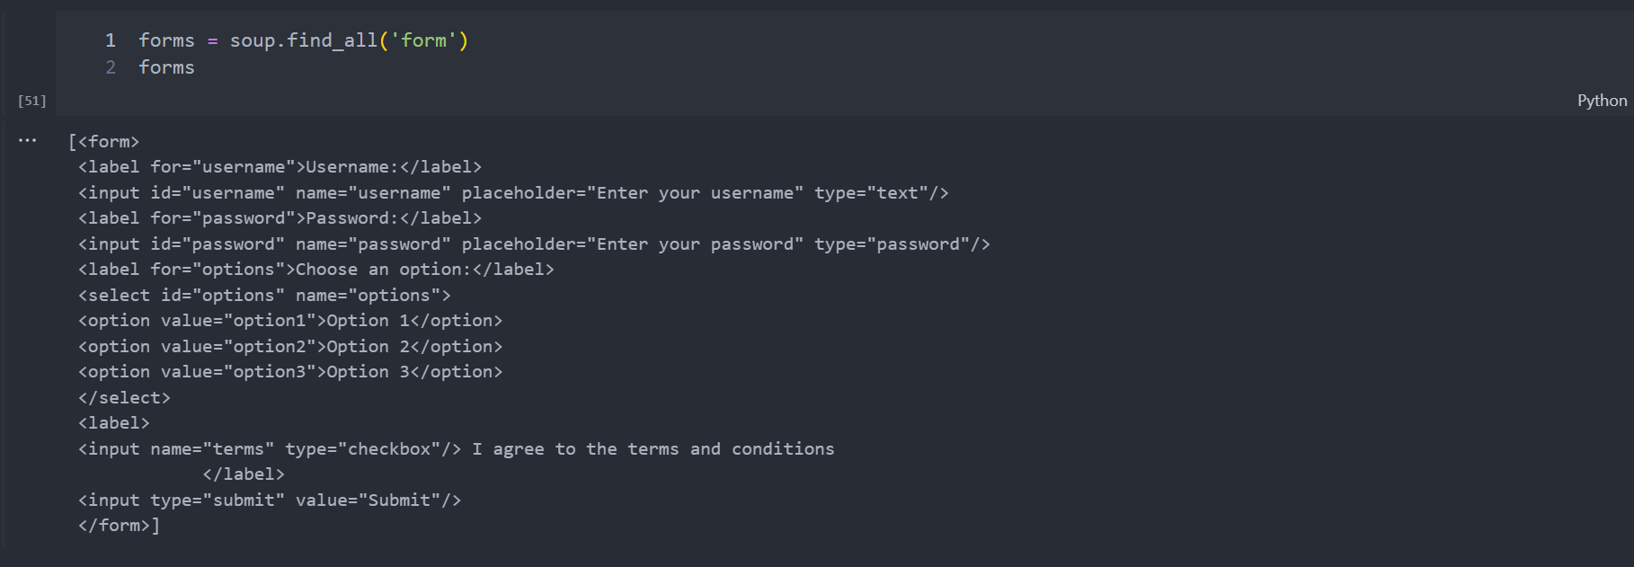

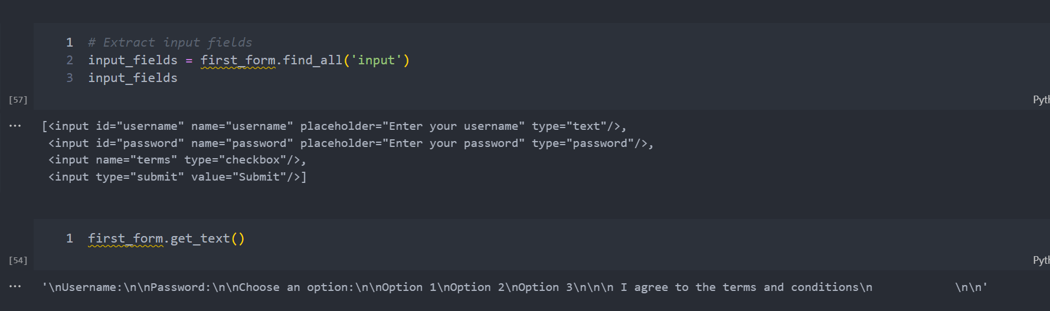

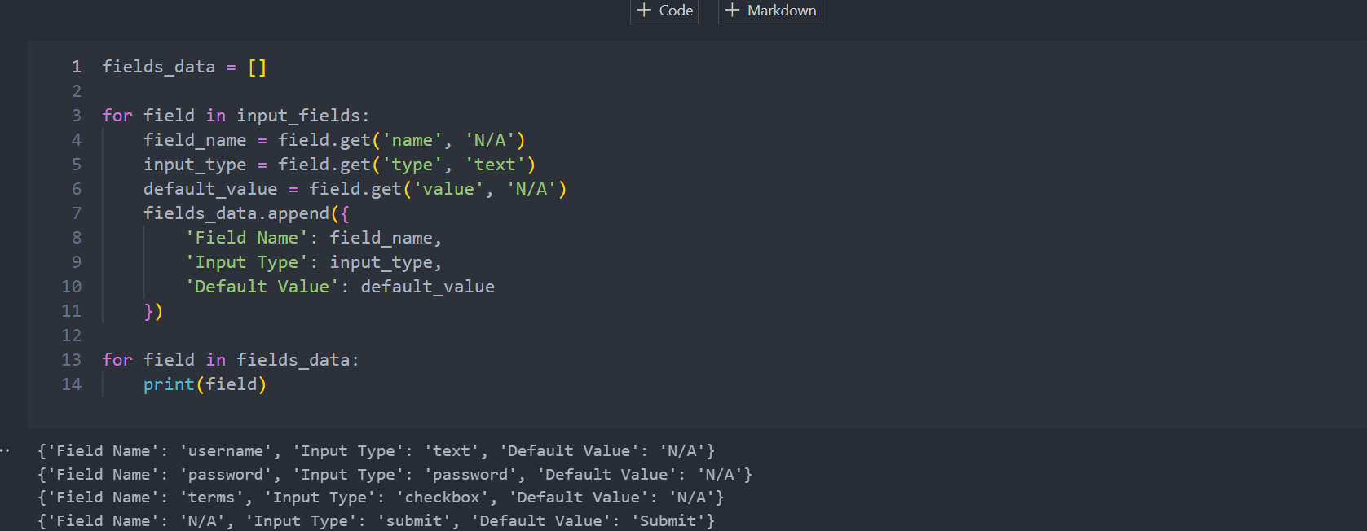

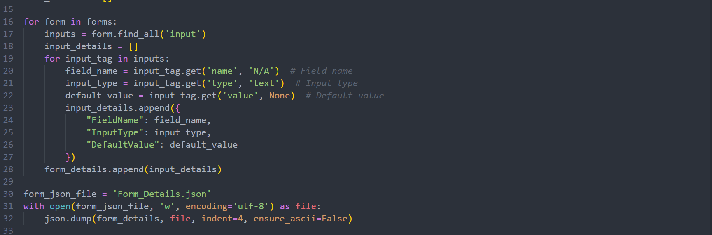

**Task 5**

* **Extract Links and Multimedia:**

**● Extract the hyperlink (<a> tag) and its href value.**

**● Extract the video link from the <iframe> tag.**

**● Savethedata into a JSON file.**

**●** [**https://www.geeksforgeeks.org/how-to-convert-python-dictionary-to-json/**](https://www.geeksforgeeks.org/how-to-convert-python-dictionary-to-json/)

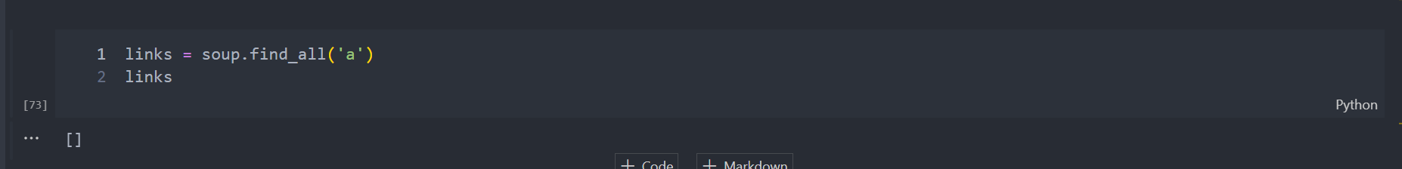

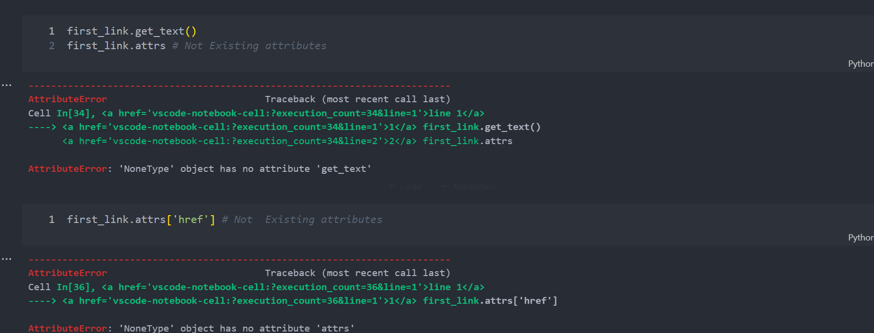

>>>>>> No <a> in the site

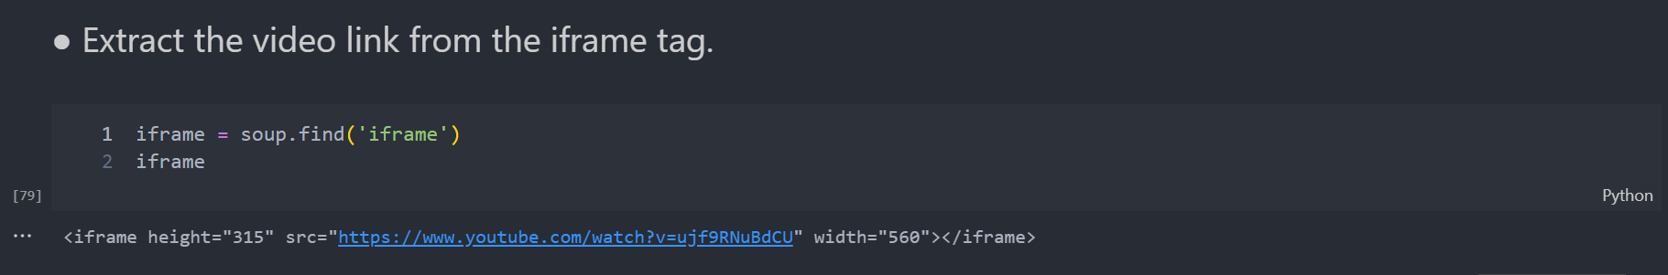

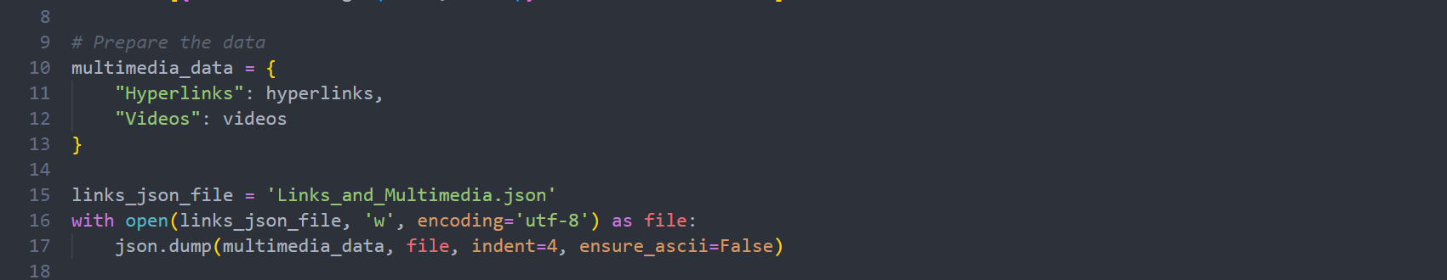

**Task 6**

* **Scraping Challenge**

**● Product Name: Located within <span class="name">.**

**● HiddenPrice: Located within <span class="price">, which has style="display: none;".**

**● Available Colors: Located within <span class="colors">.**

**● Product ID: The value stored in the data-id attribute.**

**● ExampleOutput:**

**[**

**{'id': '101', 'name': 'Wireless Headphones', 'price': '$49.99', 'colors': 'Black, White, Blue'},**

**{'id': '102', 'name': 'Smart Speaker', 'price': '$89.99', 'colors': 'Grey, Black'},**

**{'id': '103', 'name': 'Smart Watch', 'price': '$149.99', 'colors': 'Black, Silver, Gold'}**

**]**

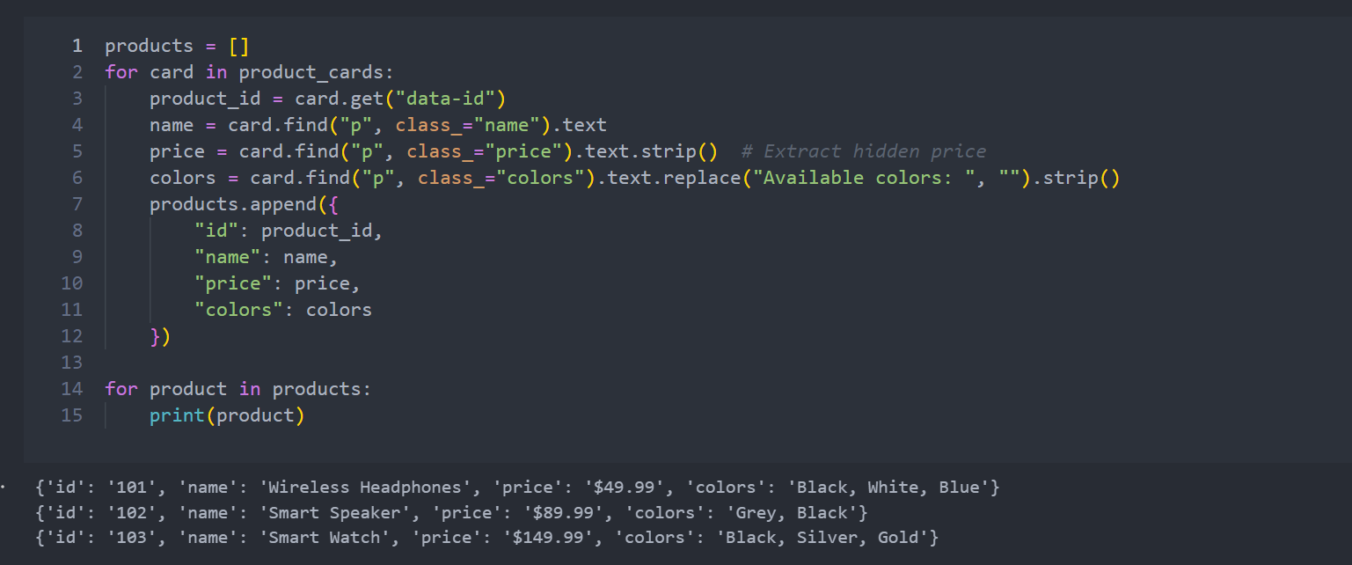

**Thanks**